**Test Plan**

**for**

**Personal Budget Manager Application**

**Version 1.4**

**Prepared by**

|  |  |  |
| --- | --- | --- |
| **Name** | **Student ID** | **e-mail** |
| **Danny Shash** | **29548912** | **danny.shash@gmail.com** |
| **Ganji Amarendher** | **25764246** | **a_ganji@encs.concordia.ca** |
| **Siming Huang** | **40081588** | **hsim47@163.com** |
| **Tony Lac** | **40049123** | **tony.lac@polymtl.ca** |
| **Xinjie Zeng** | **27238223** | **xinjiezeng@gmail.com** |

**Revision History**

|  |  |  |  |
| --- | --- | --- | --- |
| **Date** | **Version** | **Description** | **Author** |
| 31/01/2019 | 1.0 | Test plan for increment 1 | Xinjie Zeng |
| 18/03/2019 | 1.1 | Test plan for increment 2 | Xinjie Zeng |
| 03/04/2019 | 1.3 | Test plan for increment 3 | Xinjie Zeng Siming Huang Tony Lac Danny Shash |

TABLE OF CONTENTS

1. Introduction 3

1.1 Purpose 3

1.2 Scope 3

1.3 Document Terminology and Acronyms 3

**1.3.1 Definitions** 3

**1.3.2 Acronyms** 4

1.4 References 4

2. Target Test Items 4

2.1 Unit Testing 4

2.2 Integration Testing 4

2.3 Function Testing 4

2.4 User Interface Testing 5

2.5 Configuration Testing 5

3. Test Approach 6

3.1 Unit Testing 6

3.1.1 Model 6

3.1.2 View 11

3.1.3 Controller 17

3.2 Integration Testing 24

3.2.1 userInterface panel 24

3.2.2 addCompositeExpense panel 24

3.2.3 addExpense panel 24

3.3 Function Testing 25

3.3.1 Add an expense 25

3.3.2 Create Composite Expense 28

3.3.3 Mark Expense Paid/Unpaid 29

3.3.4 Remove Expense 33

3.3.5 Hide/Show Paid Expenses 35

3.4 User Interface Testing 39

3.4.1 Main Panel 40

3.4.2 Add Expense 41

3.4.3 Remove Expense 43

3.4.4 Mark Expense Paid/Unpaid 45

3.4.5 Hide/Show Paid Expenses 46

3.4.6 Create Composite Expense 48

3.4.7 Moving the Window 50

3.4.8 Exit the Application 50

3.5 Configuration Testing 50

4. Testing Workflow 50

4.1 Test Plan & Software Engineering process 51

4.2 Work Flow of a Test 51

4.3 Workflow of Fixing Bugs 51

5. Iteration Milestones 52

List of Figures

Figure 1. Path diagram for function: add 7

Figure 2. Path diagram for function: remove 8

Figure 3. Path diagram for function: getBillsList 10

Figure 4. Path diagram for function: update 12

Figure 5. Path diagram for function: getData 16

Figure 6. Path diagram for function: put 18

Figure 7. Path diagram for function: remove 21

Figure 8. Path diagram for function: modify 23

# **1.** **Introduction**

The primary goal of this project is to develop a personal budget manager application, which users can manage and track their personal expenses. This is the final phase of the project, which contains a comprehensive list of tests that will be performed along with a workflow of how the tests will be executed.

## **1.1 Purpose**

The purpose of the test plan is to gather all of the information necessary to plan and control the test effort for this phase. The Test Plan document supports the following objectives:

* + List the recommended test requirements
  + Describe the testing strategies and approaches to be employed
  + Describe the workflow of the testing process that must be executed
  + Provide a timeline with milestones for the testing phase

## **1.2** **Scope**

This test plan is to test the Personal Budget Manager Application. The test plan will cover unit, integration, function, and user interface testing. Testing techniques that will be performed include white box, black box testing as well as boundary testing. A test plan workflow will also be included along with milestones for this phase.

## **1.3 Document Terminology and Acronyms**

**1.3.1 Definitions**

Purchase A type of day-to-day expense

Bill A type of recurring expense

**1.3.2 Acronyms**

PBM Personal Budget Manager Application

SRS Software Requirement Specification

SDD Software Design Document

## **1.4 References**

* Pressman, Roger S. Software Engineering: A Practitioner's Approach. 5th ed. Toronto: McGraw-Hill, 2001.
* Dr. Nora Houari, "COMP 354 Software Engineering – Validation and Verification, Testing" <https://moodle.concordia.ca/moodle/pluginfile.php/3554573/mod_label/intro/se-vv-test.pdf> (Current April 1, 2018)

# **2. Target Test Items**

In this section, we will list all the target test items and the detailed test plans.

## **2.1 Unit Testing**

Unit testing consists of testing different units of the system. We test classes and methods in isolation using white box and black box techniques. The list of test items for unit testing will not cover all the classes and methods. It will focus on classes and methods that implement major functions (please refer to the design document). Below is a list of the test items:

* Function add
* Function remove
* Function modify payment status

## **2.2 Integration Testing**

We will test components (models, views and controller) separately, and then integrating them together and test it again.

## **2.3 Function Testing**

It will consist of all the requirements and specifications in the SRS. We include detailed test cases for all the functionalities. Below is the list of functions that were tested:

* Add a purchase
* Add a bill
* Add a composite purchase
* Add a composite bill
* Remove a purchase
* Remove a bill
* Remove a composite purchase
* Remove a composite bill
* Modify payment status
* Show/hide the expense
* View all expenses on the major panel

## **2.4 User Interface Testing**

User interface testing is to make sure the user interface works as required in the software requirement document and software design document. For the user interface, the possible interactions will be tested in great detail. The user interface will be covered include:

* addCompositeExpense panel
* addExpense panel
* userInterface panel

## **2.5 Configuration Testing**

Configuration testing makes sure the PBM application runs successfully in different environment configurations. We have tested the PBM application under different operation system:

* Windows
* Mac

# **3. Test Approach**

The test approach describes the strategies to design and implement the tests. In this section, we will describe the details of the tests for each target test item in section 3.

## **3.1 Unit Testing**

### 3.1.1 Model

#### 3.1.1.1 CompositeBillTest

##### 3.1.1.1.1 add Function

###### 3.1.1.1.1.1 Black Box Testing



###### 3.1.1.1.1.2 White Box Testing

public void add(Expense expense) {

1

expense.setParent(this);

items.add(expense);

2

this.setNoOfSubItems(this.getNoOfSubItems()+1);

3

}

|  |  |
| --- | --- |
| Path 1 | 1-2-3 |

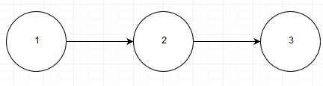

Figure 1. Path diagram for function: add

##### 3.1.1.1.2 remove Function

###### 3.1.1.1.2.1 Black Box Testing



###### 3.1.1.1.2.2White Box Testing

public boolean remove(Expense expense) {

if(items.size()>0) {

1

items.remove(expense);

this.setNoOfSubItems(this.getNoOfSubItems()-1);

2

return true;

}

3

return false;

}

|  |  |
| --- | --- |
| Path 1 | 1-3 |
| Path 2 | 1-2 |

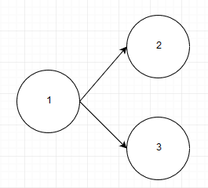

Figure 2. Path diagram for function: remove

##### 3.1.1.1.3 getBillsList Function

###### 3.1.1.1.3.1 Black Box Testing



###### 3.1.1.1.3.2White Box Testing

items=new ArrayList<Expense>()

private ArrayList<Expense> getBillsList(ArrayList<Expense> list) {

Iterator<Expense> compBill = items.iterator();

1

2

while(compBill.hasNext())

{

3

Expense e = compBill.next();

list.add(e);

if(e.getType().ordinal()>1) {

4

CompositeBill ce= (CompositeBill)e;

5

ce.getBillsList(list);

}

}

6

return list;

}

|  |  |
| --- | --- |
| Path 1 | 1-2-6 |
| Path 2 | 1-2-3-2(loop)-6 |
| Path 3 | 1-2-3-4-5-1(loop)-2(loop)-6 |

|  |  |
| --- | --- |
| Path 1 | 1-2-6 |
| Objects | List list, Iterator compBill, List items |
| Result | Only one expense item in the Iterator. Therefore it cannot be a composite.  Therefore *return list.* |

|  |  |
| --- | --- |
| Path 2 | 1-2-3-2(loop)-6 |
| Objects | List list, Iterator compBill, List items, Expense e, Expense ce |
| Result | More than expense item in the Iterator. However, none of them are composites because there *getType* index number is 1 or less.Step 2 is repeated until there are no more objects in the iterator and exits to step 6 and *return list.* |

|  |  |
| --- | --- |
| Path 3 | 1-2-3-4-5-1(loop)-2(loop)-6 |
| Objects | List list, Iterator compBill, List items, Expense e, Expense ce |
| Result | *CompositeBill ce* is created at step 5, and subsequent Bill *Expenses e* are added to the list. If e.getType is larger is 2+, further *CompositeBill ce* are created and cycle repeats itself from step 1 until step2 cannot be activated and the *return list* is activated |

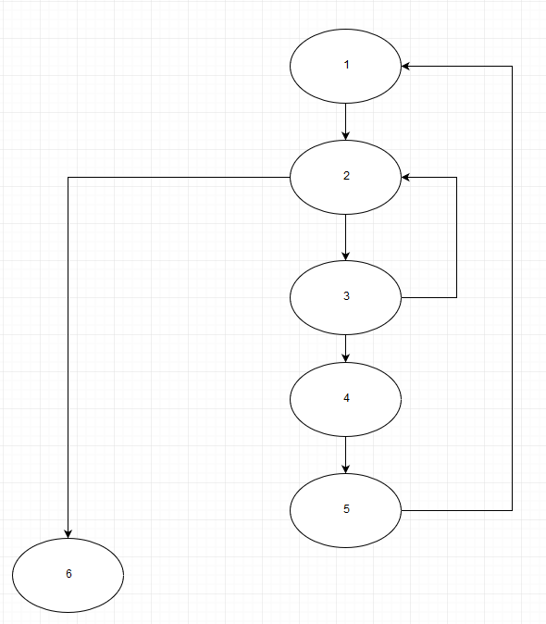

Figure 3. Path diagram for function: getBillsList

### 3.1.2 View

#### 3.1.2.1 ExpenseObserverImplTest

##### 3.1.2.1.1 testUpdate Function

###### 3.1.2.1.1.1 Black Box Testing



###### 3.1.2.1.1.2 White Box Testing

public void update(List<Map<ExpenseKey , Expense>> data) {

) )

133213

this.ldata = data;

System.out.println("Data state changed, please refresh the view! items="+

) )

ldata.get(0).size()+", " + //purchase

ldata.get(1).size()+", " + //bill

233213

ldata.get(2).size()+", " + //comp_purchase

ldata.get(3).size() //comp_bill

);

333213

) )

UserInterface.getInstance().getTableModel().refresh();

433213

) )

subject.resetStateChange();

}

|  |  |
| --- | --- |
| Path 1 | 1-2-3-4 |

|  |  |
| --- | --- |
| Path 1 | 1-2-3-4 |
| Object | List data |
| Expected Results | Step2:“Data state changed, please refresh the view! items=2, 3, 1, 1”//Amount of expensese in maps for purchase, bill, comp_purchase and comp_bill are updated in the Idata Arraylist.  Step3: Userinterface table model is updated  Step4: if any changes is in the UI Expenses not saved is lost. |

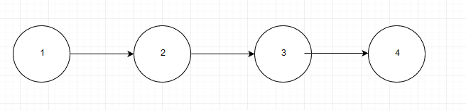

Figure 4. Path diagram for function: update

##### 3.1.2.1.2 testGetData Function

###### 3.1.2.1.2.1 Black Box Testing



###### 3.1.2.1.2.2 White Box Testing

private static final ExpenseObserver expenseObserver = new ExpenseObserverImpl();

private ExpenseSubject subject;

private List<Map<ExpenseKey , Expense>> ldata=null;

public ArrayList<Expense> getData(DisplayParameters params) {

ArrayList<Expense> expList = null;

11

if(ldata.get(params.type.ordinal()) == null) {

12

System.out.println("reurning as data is null, refresh");

return expList;

}

3

switch(params.type.ordinal())

{

case 0:

expList = new ArrayList<Expense>();

ArrayList<Expense> purchase_List =

4

new ArrayList<Expense>(ldata.get(0).values());

expList.addAll(purchase_List);

break;

case 2:

expList = new ArrayList<Expense>();

5

ArrayList<Expense> comp_purchase_List =

new ArrayList<Expense>(ldata.get(2).values());

expList.addAll(comp_purchase_List);

break;

case 1:

expList = new ArrayList<Expense>();

6

ArrayList<Expense> bill_List = new ArrayList<Expense>(ldata.get(1).values());

expList.addAll(bill_List);

break;

case 3:

expList = new ArrayList<Expense>();

7

ArrayList<Expense> comp_bill_List =

new ArrayList<Expense>(ldata.get(3).values());

expList.addAll(comp_bill_List);

break;

default:

8

throw new RuntimeException("getExpenses error");

}

return expList;

9

}

|  |  |
| --- | --- |
| Path 1 | 1-2-9 |
| Path 2 | 1-3-8-9 |
| Path 3 | 1-3-4-9 |
| Path 4 | 1-3-5-9 |
| Path 5 | 1-3-6-9 |
| Path 6 | 1-3-7-9 |

|  |  |
| --- | --- |
| Path 1 | 1-2-9 |
| Object | DisplayParameters params, ArrayList expList, ExpenseType type |
| Expected Results | System.out.println("returning as data is null, refresh"); |

|  |  |
| --- | --- |
| Path 2 | 1-3-8-9 |
| Object | DisplayParameters params, ArrayList expList, ExpenseType type |
| Expected Results | RuntimeException("getExpenses error"); |

|  |  |
| --- | --- |
| Path 3 | 1-3-4-9 |
| Object | DisplayParameters params, ArrayList expList, ExpenseType type |
| Expected Results | return expList.addAll(purchase_List); |

|  |  |
| --- | --- |
| Path 4 | 1-3-5-9 |
| Object | DisplayParameters params, ArrayList expList, ExpenseType type |
| Expected Results | return expList.addAll(comp_purchase_List); |

|  |  |
| --- | --- |
| Path 5 | 1-3-6-9 |
| Object | DisplayParameters params, ArrayList expList, ExpenseType type |
| Expected Results | return expList.addAll(bill_List); |

|  |  |
| --- | --- |
| Path 6 | 1-3-6-9 |
| Object | DisplayParameters params, ArrayList expList, ExpenseType type |
| Expected Results | return expList.addAll(comp_bill_List); |

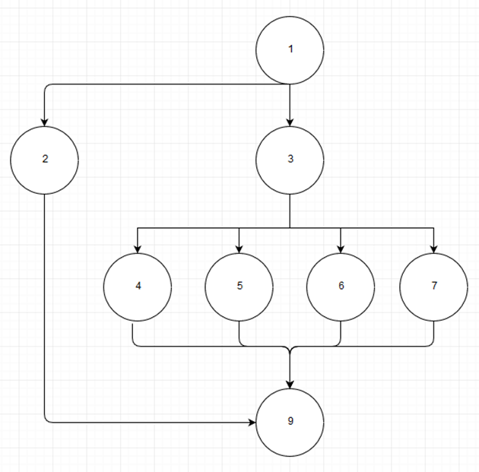

Figure 5. Path diagram for function: getData

### 3.1.3 Controller

### 

#### 3.1.3.1 InMemoryStoreTest

##### 3.1.3.1.1 put Function

###### 3.1.3.1.1.1 Black Box Testing



###### 3.1.3.1.1.2 White Box Testing

private List<Map<ExpenseKey , Expense>> expenseData;

private Map<ExpenseKey , Expense> purchases;

private Map<ExpenseKey , Expense> comp_purchases;

private Map<ExpenseKey , Expense> bill;

private Map<ExpenseKey , Expense> comp_bill;

public void put(Expense expense) throws IOException {

switch(expense.getType().ordinal()){

1

case 0 : purchases.put(expense.getKey(), expense);

2

break;

case 1 : bill.put(expense.getKey(), expense);

3

break;

case 2 : comp_purchases.put(expense.getKey(), expense);

415

break;

5

case 3 : comp_bill.put(expense.getKey(), expense);

break;

default:

6

throw new RuntimeException("Invalid Expense type");

}

}

|  |  |
| --- | --- |
| Path 1 | 1-2 |
| Path 2 | 1-3 |
| Path 3 | 1-4 |
| Path 4 | 1-5 |
| Path 5 | 1-6 |

|  |  |
| --- | --- |
| Path 1 | 1-2 |
| Objects | Expense expense, Map purchases |
| Result | expense is added to Map purchase with unique key |

|  |  |
| --- | --- |
| Path 2 | 1-3 |
| Objects | Expense expense, Map bill |
| Result | expense is added to Map bill with unique key |

|  |  |
| --- | --- |
| Path 3 | 1-4 |
| Objects | Expense expense, Map comp_purchases |
| Result | expense is added to Map comp_purchases with unique key |

|  |  |
| --- | --- |
| Path 4 | 1-5 |
| Objects | Expense expense, Map comp_bill |
| Result | expense is added to Map comp_bill with unique key |

|  |  |
| --- | --- |
| Path 5 | 1-6 |
| Objects | Expense expense |
| Result | RuntimeException("Invalid Expense type"); |

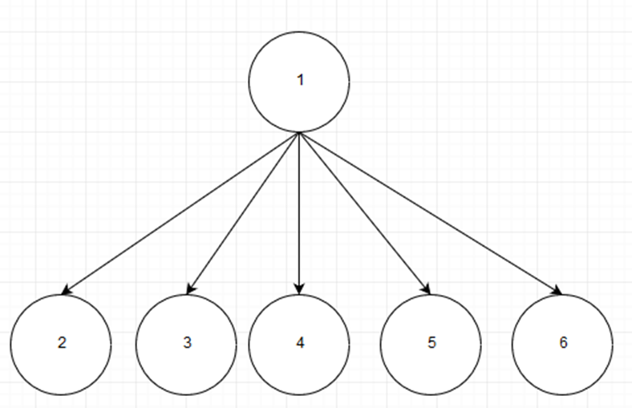

Figure 6. Path diagram for function: put

##### 3.1.3.1.2 remove Function

###### 3.1.3.1.2.1 Black Box Testing



###### 3.1.3.1.2.2 White Box Testing

private List<Map<ExpenseKey , Expense>> expenseData;

private Map<ExpenseKey , Expense> purchases;

private Map<ExpenseKey , Expense> comp_purchases;

private Map<ExpenseKey , Expense> bill;

private Map<ExpenseKey , Expense> comp_bill;

public void remove(Expense expense) throws IOException {

1

switch(expense.getType().ordinal(){

2

case 0 : purchases.remove(expense.getKey(), expense);

break;

3

case 1 : bill.remove(expense.getKey(), expense);

break;

case 2 :comp_purchases.remove(expense.getKey(), expense);

4

break;

case 3 : comp_bill.remove(expense.getKey(), expense);

5

break;

default:

61

throw new RuntimeException() ;

}

}

}

|  |  |
| --- | --- |
| Path 1 | 1-2 |
| Path 2 | 1-3 |
| Path 3 | 1-4 |
| Path 4 | 1-5 |
| Path 5 | 1-6 |

|  |  |
| --- | --- |
| Path 1 | 1-2 |
| Objects | Expense expense, Map purchases |
| Result | expense is removed from Map purchase with its unique key |

|  |  |
| --- | --- |
| Path 2 | 1-3 |
| Objects | Expense expense, Map bill |
| Result | expense is removed from Map bill with its unique key |

|  |  |
| --- | --- |
| Path 3 | 1-4 |
| Objects | Expense expense, Map comp_purchases |
| Result | expense is removed from Map comp_purchases with its with unique key |

|  |  |
| --- | --- |
| Path 4 | 1-5 |
| Objects | Expense expense, Map comp_bill |
| Result | expense is removed from Map comp_bill with its unique key |

|  |  |
| --- | --- |
| Path 5 | 1-6 |
| Objects | Expense expense |
| Result | throw new RuntimeException(); |

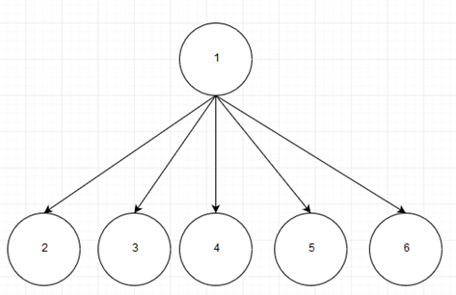

Figure 7. Path diagram for function: remove

##### 3.1.3.1.3 modify Function

###### 3.1.3.1.3.1 Black Box Testing



###### 3.1.3.1.3.2 White Box Testing

public boolean modify(Expense from, Expense to) {

//Let's check if they are same

if(!from.iseqal(to)) {

1

return false;

}

2

try {

this.remove(from);

}

catch (IOException e) {

3

// TODO Auto-generated catch block

e.printStackTrace();

}

switch(from.getType().ordinal()){

4

case 0 : purchases.put(to.getKey(), to);

5

break;

case 1 : bill.put(to.getKey(), to);

6

break;

case 2 : comp_purchases.put(to.getKey(), to);

7

break;

case 3 : comp_bill.put(to.getKey(), to);

break;

8

default:

9

throw new RuntimeException() ;

}

return true;

10

}

|  |  |
| --- | --- |
| Path 1 | 1 |
| Path 2 | 1-3 |
| Path 3 | 1-2-4-9 |
| Path 4 | 1-2-4-5-10 |
| Path 5 | 1-2-4-6-10 |
| Path 6 | 1-2-4-7-10 |
| Path 7 | 1-2-4-8-10 |

|  |  |
| --- | --- |
| Path 1 | 1 |
| Objects | Expense from, Expense to |
| Result | return false;// The expense has not been modified for any changes |

|  |  |
| --- | --- |
| Path 2 | 1-3 |
| Objects | Expense from, Expense to |
| Result | e.printStackTrace();// Expense *from* cannot be removed due to system bug. |

|  |  |
| --- | --- |
| Path 3 | 1-2-4-9 |
| Objects | Expense from, Expense to |
| Result | throw new RuntimeException();// Expense fr*om* type number is out of bound |

|  |  |
| --- | --- |
| Path 4 | 1-2-4-5-10 |
| Objects | Expense from, Expense to |
| Result | expense *from* is removed and expense *to* is put into Map purchases with its unique key |

|  |  |
| --- | --- |
| Path 5 | 1-2-4-6-10 |
| Objects | Expense from, Expense to |
| Result | Expense *from* is removed and expense *to* is put into Map *bill* with its unique key |

|  |  |
| --- | --- |
| Path 6 | 1-2-4-7-10 |
| Objects | Expense from, Expense to |
| Result | Expense *from* is removed and expense *to* is put into Map *comp_purchases* with its unique key |

|  |  |
| --- | --- |
| Path 7 | 1-2-4-8-10 |
| Objects | Expense from, Expense to |
| Result | Expense *from* is removed and expense *to* is put into Map *comp_purchases* with its unique key |

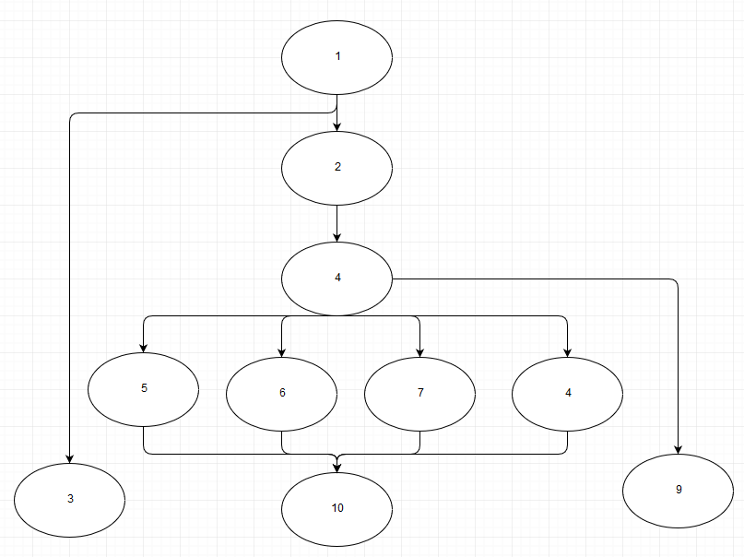

Figure 8. Path diagram for function: modify

## **3.2 Integration Testing**

The purpose of the integration testing is to ensure the proper navigation of PBM application and ease of use for users. We will navigate through window to window, verify key and mouse movement. For each integration test, we design several test cases. In each test case, exactly one new component will be analyzed.

### 3.2.1 userInterface panel

|  |  |
| --- | --- |
| Test Case 1 | Initialize the window |
| Test Case Description | To test if the window can initialize normally  This test case should be done when we run the code |
| Test Result | OK |

|  |  |
| --- | --- |
| Test Case 2 | Open addCompositeExpense panel |
| Test Case Description | Select multiple purchases or bills (not both) and click the Create Composite Expense button to test if the addCompositeExpense panel can be opened. |
| Test Result | OK |

|  |  |
| --- | --- |
| Test Case 3 | Open addExpense panel |
| Test Case Description | Click the Add Expense button to test if the addExpense panel can be opened. |
| Test Result | OK |

### 3.2.2 addCompositeExpense panel

|  |  |
| --- | --- |
| Test Case 1 | show new composite expense on userInterface panel |
| Test Case Description | The new composite expense should be displayed on the userInterface panel when user clicks Add Expense button on addCompositeExpense panel. |
| Test Result | OK |

|  |  |
| --- | --- |
| Test Case 2 | Close addCompositeExpense panel |
| Test Case Description | The addCompositeExpense panel should be closed automatically when user clicks Add Expense button on addCompositeExpense panel. |
| Test Result | OK |

### 3.2.3 addExpense panel

|  |  |
| --- | --- |
| Test Case 1 | show new expense on userInterface panel |
| Test Case Description | The new expense should be displayed on the userInterface panel when user clicks Add Expense button on addExpense panel. |
| Test Result | OK |

|  |  |
| --- | --- |
| Test Case 2 | Close addExpense panel |
| Test Case Description | The addExpense panel should be closed automatically when user clicks Add Expense button on addExpense panel. |
| Test Result | OK |

## **3.3 Function Testing**

This section tests the functions of the software. Each requirement is associated with a set of test cases, with valid data and invalid data.

### 3.3.1 Add an expense

|  |  |
| --- | --- |
| Test case | Add a purchase |
| Test Case Description | 1. open the app  2. click “Add Expense” button on main panel  3. type in info  4. press “Add Expense button” on Add Expense panel |
| Test data | Type: purchase  Date: 2018-07-19  Name: candy  Amount: 2.62  Status: paid  Method: debit  Vendor Name: Tim Hortons  Location: Downtown  Category: Food |
| Expected result | store the info in the data base and show it on the main panel |
| Actual result | Successfully stores the info in the data base and update it on the main panel |

|  |  |
| --- | --- |
| Test case | Add a bill |
| Test Case Description | 1. open the app  2. click “Add Expense” button on main panel  3. type in info  4. press “Add Expense button” on Add Expense panel |
| Test data | Type: bill  Date: 2018-08-19  Name: jenny  Amount: 50  Status: unpaid  Vendor Name: Fido  Location: Downtown  Method: credit  Category: Utilities  Due date: 2019-09-19  Interval: Monthly |
| Expected result | store the info in the data base and update it on the main panel |
| Actual result | Successfully stores the info in the data base and update it on the main panel |

|  |  |
| --- | --- |
| Test case | Add a purchase (invalid date) |
| Test Case Description | 1. open the app  2. click “Add Expense” button on main panel  3. type in info  4. press “Add Expense button” on Add Expense panel |
| Test Data | Type: purchase  Date: dkejide  Name: candy  Amount: 2.62  Status: paid  Method: debit  Vendor Name: Tim Hortons  Location: Downtown  Category: Food |
| Expected result | The “Add Expense” button become unclickable. There is a red sentence besides the Date to ask user to type in date in correct format like 2019-09-09. If the info is correct, “Add Expense” button will become clickable and the red word disappears. |
| Actual result | Successfully implement the above scenario |

|  |  |
| --- | --- |
| Test case | Add a purchase (invalid amount) |
| Test Case Description | 1. open the app  2. click “Add Expense” button on main panel  3. type in info  4. press “Add Expense button” on Add Expense panel |
| Test data | Type: purchase  Date: 2019-03-07  Name: candy  Amount: dfsdf  Status: paid  Method: debit  Vendor Name: Tim Hortons  Location: Downtown  Category: Food |
| Expected result | The “Add Expense” button become unclickable. There is a red sentence besides the amount to ask user to type in correct format like 74.55. If the info is correct, “Add Expense” button will become clickable and the red word disappears. |
| Actual result | Successfully implement the above scenario |

|  |  |
| --- | --- |
| Test case | Add a bill (invalid date) |
| Test Case Description | 1. open the app  2. click “Add Expense” button on main panel  3. type in info  4. press “Add Expense button” on Add Expense panel |
| Test data | Type: bill  Date: sdfsdfew  Name: jenny  Amount: 50  Status: unpaid  Vendor Name: Fido  Location: Downtown  Method: credit  Category: Utilities  Due date: 2019-09-19  Interval: Monthly |
| Expected result | The “Add Expense” button become unclickable. There is a red sentence besides the Date to ask user to type in date in correct format like 2019-09-09. If the info is correct, “Add Expense” button will become clickable and the red word disappears. |
| Actual result | Successfully implement the above scenario |

|  |  |
| --- | --- |
| Test case | Add a bill (invalid amount) |
| Test Case Description | 1. open the app  2. click “Add Expense” button on main panel  3. type in info  4. press “Add Expense button” on Add Expense panel |
| Test data | Type: purchase  Date: 2019-03-07  Name: candy  Amount: dfsdf  Status: paid  Method: debit  Vendor Name: Tim Hortons  Location: Downtown  Category: Food |
| Expected result | The “Add Expense” button become unclickable. There is a red sentence besides the amount to ask user to type in correct format like 74.55. If the info is correct, “Add Expense” button will become clickable and the red word disappears. |
| Actual result | Sucessfully implement the above scenario |

### 3.3.2 Create Composite Expense

|  |  |
| --- | --- |
| Test case | Create a composite bill |
| test steps | 1. open the app  2. select multiple bills on the main panel  3. click the “Create Composite Expense” button |
| Test Case Description | Type: bill  Date: 2018-08-19  Name: jenny  Amount: 50  Status: unpaid  Vendor Name: Fido  Location: Downtown  Method: credit  Category: Utilities  Due date: 2019-09-19  Interval: Monthly  Type: bill  Date: 2019-01-01  Name: Gym  Amount: 750  Status: paid  Vendor Name: ABC Fitness  Location:  Method:  Category: Default  Due date: 2019-04-01  Interval: Monthly |
| Expected result | These two bills are shown under the composite bill on the panel. |
| Actual result | Successfully create composite bill |

|  |  |
| --- | --- |
| Test case | Create a composite purchase |
| Test Case Description | 1. open the app  2. select multiple purchases on the main panel  3. click the “Create Composite Expense” button |
| Test data | Type: purchase  Date: 2019-03-07  Name: candy  Amount: 30.5  Status: paid  Method: debit  Vendor Name: Tim Hortons  Location: Downtown  Category: Food  Type: purchase  Date: 2019-01-27  Name: cakes  Amount: cocobun  Status: paid  Method: debit  Vendor Name: Tim Hortons  Location: Downtown  Category: Food |
| Expected result | These two purchases are shown under the composite purchase on the panel. |
| Actual result | Successfully creates a composite purchase |

### 3.3.3 Mark Expense Paid/Unpaid

|  |  |
| --- | --- |
| Test Case | Mark a purchase unpaid to paid |
| Test Case Description | 1. open the app  2. select an expense  3. click “Mark Expense Paid/Unpaid” button |
| Test data | Type: purchase  Date: 2019-03-18  Name: gas  Amount: 62.94  Status: unpaid  Method: credit  Vendor: Petrol Canada  Location:  Category: default  Due Date: 2019-03-28 |
| Expected result | The purchase status changed from unpaid to paid. |
| Actual result | Successfully updated the purchase status to paid. |

|  |  |
| --- | --- |
| Test Case | Mark a purchase paid to unpaid |
| Test Case Description | 1. open the app  2. select an expense  3. click “Mark Expense Paid/Unpaid” button |
| Test data | Type: purchase  Date: 2019-03-18  Name: gas  Amount: 62.94  Status: paid  Method: credit  Vendor: Petrol Canada  Location:  Category: default  Due Date: 2019-03-28 |
| Expected result | The purchase status changed from paid to unpaid. |
| Actual result | Successfully updated the purchase status to unpaid. |

|  |  |
| --- | --- |
| Test case | Mark a bill unpaid to paid |
| Test Case Description | 1. open the app  2. select an expense  3. click “Mark Expense Paid/Unpaid” button |
| Test data | Type: bill  Date: 2019-01-18  Name: Electricity  Amount: 576.93  Status: unpaid  Method:  Vendor: Hydro Quebec  Location:  Category: default  Due Date: 2019-03-18  Interval: Quarterly |
| Expected result | The bill status changed from unpaid to paid. |
| Actual result | Successfully updated the bill status to paid. |

|  |  |
| --- | --- |
| Test Case | Mark a bill paid to unpaid |
| Test Case Description | 1. open the app  2. select an expense  3. click “Mark Expense Paid/Unpaid” button |
| Test data | Type: bill  Date: 2019-03-18  Name: gas  Amount: 62.94  Status: paid  Method: credit  Vendor: Petrol Canada  Location:  Category: default  Due Date: 2019-03-28  Interval: Monthly |
| Expected result | The purchase status changed from paid to unpaid. |
| Actual result | Successfully updated the purchase status to unpaid. |

|  |  |
| --- | --- |
| Test Case | mark a composite purchase unpaid to paid |
| Test Case Description | 1. open the app  2. select composite purchase on the main panel  3. click the “Mark Expense Paid/Unpaid” button |
| Test data | Type: composite purchase  Date: 2019-03-07  Name: candy  Amount: 30.5  Status: unpaid  Method: debit  Vendor Name: Tim Hortons  Location: Downtown  Category: Food  Date: 2019-01-27  Name: cakes  Amount: cocobun  Status: unpaid  Method: debit  Vendor Name: Tim Hortons  Location: Downtown  Category: Food |
| Expected result | The status of two purchases shown under the composite purchase will be updated to paid. |
| Actual result | The status of two purchases shown under the composite purchase update successfully.  The status of composite purchase updates successfully. |

|  |  |
| --- | --- |
| Test Case | mark a composite purchase paid to unpaid |
| Test Case Description | 1. open the app  2. select composite purchase on the main panel  3. click the “Mark Expense Paid/Unpaid” button |
| Test data | Type: composite purchase  Date: 2019-03-07  Name: candy  Amount: 30.5  Status: paid  Method: debit  Vendor Name: Tim Hortons  Location: Downtown  Category: Food  Date: 2019-01-27  Name: cakes  Amount: cocobun  Status: paid  Method: debit  Vendor Name: Tim Hortons  Location: Downtown  Category: Food |
| Expected result | The status of two purchases shown under the composite purchase will be updated to unpaid. |
| Actual result | The status of two purchases shown under the composite purchase update successfully.  The status of composite purchase updates successfully. |

|  |  |
| --- | --- |
| Test Case | mark a composite bill unpaid to paid |
| Test Case Description | 1. open the app  2. select composite bill on the main panel  3. click the “Mark Expense Paid/Unpaid” button |
| Test data | Type: composite bill  Date: 2018-08-19  Name: jenny  Amount: 50  Status: unpaid  Vendor Name: Fido  Location: Downtown  Method: credit  Category: Utilities  Due date: 2019-09-19  Interval: Monthly  Date: 2019-01-01  Name: Gym  Amount: 750  Status: unpaid  Vendor Name: ABC Fitness  Location:  Method:  Category: Default  Due date: 2019-04-01  Interval: Monthly |
| Expected result | The status of two bills shown under the composite bills will be updated to paid. |
| Actual result | The status of two bills shown under the composite bill update successfully.  The status of composite bill updates successfully. |

|  |  |
| --- | --- |
| Test Case | mark a composite bill paid to unpaid |
| Test Case Description | 1. open the app  2. select composite bill on the main panel  3. click the “Mark Expense Paid/Unpaid” button |
| Test data | Type: composite bill  Date: 2018-08-19  Name: jenny  Amount: 50  Status: paid  Vendor Name: Fido  Location: Downtown  Method: credit  Category: Utilities  Due date: 2019-09-19  Interval: Monthly  Date: 2019-01-01  Name: Gym  Amount: 750  Status: paid  Vendor Name: ABC Fitness  Location:  Method:  Category: Default  Due date: 2019-04-01  Interval: Monthly |
| Expected result | The status of two bills shown under the composite bills will be updated to unpaid. |
| Actual result | The status of bills shown under the composite bill update successfully.  The status of composite bill updates successfully. |

### 3.3.4 Remove Expense

|  |  |
| --- | --- |
| Test Case | Remove a bill |
| Test Case Description | 1. open the app  2. select a bill on the main panel  2. click “Remove Expense” button on the main panel |
| Test data | Type: bill  Date: 2018-08-19  Name: jenny  Amount: 50  Status: unpaid  Vendor Name: Fido  Location: Downtown  Method: credit  Category: Utilities  Due date: 2019-09-19  Interval: Monthly |
| Expected result | data is successfully removed from the main panel |
| Actual result | Data is successfully removed from the main panel |

|  |  |
| --- | --- |
| Test Case | Remove a purchase |
| Test Case Description | 1. open the app  2. select a purchase on the main panel  2. click “Remove Expense” button on the main panel |
| Test data | Type: purchase  Date: 2018-07-19  Name: candy  Amount: 2.62  Status: paid  Method: debit  Vendor Name: Tim Hortons  Location: Downtown  Category: Food |
| Expected result | data is successfully removed from the main panel |
| Actual result | Data is successfully removed from the main panel |

|  |  |
| --- | --- |
| Test scenario | Remove a composite bill |
| Test Case Description | 1. open the app  2. select a composite bill  3. click the “Remove Expense” button |
| Test data | Type: composite bill  Date: 2018-08-19  Name: jenny  Amount: 50  Status: paid  Vendor Name: Fido  Location: Downtown  Method: credit  Category: Utilities  Due date: 2019-09-19  Interval: Monthly  Date: 2019-01-01  Name: Gym  Amount: 750  Status: paid  Vendor Name: ABC Fitness  Location:  Method:  Category: Default  Due date: 2019-04-01  Interval: Monthly |
| Expected result | These two bills should be removed from the main panel |
| Actual result | The composite bill is removed successfully. |

|  |  |
| --- | --- |
| Test Case | Remove a composite purchase |
| Test Case Description | 1. open the app  2. select composite purchase on the main panel  3. click the “Remove Expense” button |
| Test data | Type: composite purchase  Date: 2019-03-07  Name: candy  Amount: 30.5  Status: paid  Method: debit  Vendor Name: Tim Hortons  Location: Downtown  Category: Food  Date: 2019-01-27  Name: cakes  Amount: cocobun  Status: paid  Method: debit  Vendor Name: Tim Hortons  Location: Downtown  Category: Food |
| Expected result | The two purchases will be both removed from the main panel |
| Actual result | The composite purchase is removed successfully. |

### 3.3.5 Hide/Show Paid Expenses

|  |  |
| --- | --- |
| Test Case | Hide Paid Purchase |
| Test Case Description | 1. open the app  2. click “Hide/Show Paid Expenses” button on the main panel |
| Test data | Type: purchase  Date: 2018-07-19  Name: candy  Amount: 2.62  Status: paid  Method: debit  Vendor Name: Tim Hortons  Location: Downtown  Category: Food  Type: purchase  Date: 2018-03-09  Name: cakes  Amount: 5.5  Status: unpaid  Method: credit  Vendor Name: cocobun  Location: Downtown  Category: Food  Type: purchase  Date: 2018-02-19  Name: groceries  Amount: 100  Status: unpaid  Method: credit  Vendor Name: super c  Location: Downtown  Category: Food |
| Expected result | Paid purchases should be hidden from the main panel |
| Actual result | Paid purchases are successfully hidden from the main panel |

|  |  |
| --- | --- |
| Test Case | show Paid Purchase |
| Test Case Description | 1. open the app  2. click “Hide/Show Paid Expenses” button on the main panel to hide the paid purchase  3. click “Hide/Show Paid Expenses” button on the main panel to show the paid purchase again |
| Test data | Type: purchase  Date: 2018-07-19  Name: candy  Amount: 2.62  Status: paid  Method: debit  Vendor Name: Tim Hortons  Location: Downtown  Category: Food  Type: purchase  Date: 2018-03-09  Name: cakes  Amount: 5.5  Status: unpaid  Method: credit  Vendor Name: cocobun  Location: Downtown  Category: Food  Type: purchase  Date: 2018-02-19  Name: groceries  Amount: 100  Status: unpaid  Method: credit  Vendor Name: super c  Location: Downtown  Category: Food |
| Expected result | Paid data should be reappeared on the main panel |
| Actual result | Paid data is successfully reappeared on the main panel |

|  |  |
| --- | --- |
| Test Case | Hide Paid bill |
| Test Case Description | 1. open the app  2. click “Hide/Show Paid Expenses” button on the main panel |
| Test data | Type: bill  Date: 2018-08-19  Name: jenny  Amount: 50  Status: unpaid  Vendor Name: Fido  Location: Downtown  Method: credit  Category: Utilities  Due date: 2019-09-19  Interval: Monthly  Type: bill  Date: 2018-08-19  Name: electricity  Amount: 150  Status: unpaid  Vendor Name: Hydro Quebec  Location:  Method: credit  Category: default  Due date: 2018-11-19  Interval: Quarterly  Type: bill  Date: 2019-01-19  Name: parking  Amount: 150  Status: paid  Vendor Name: Indigo  Location: Downtown  Method: credit  Category: Utilities  Due date: 2019-02-19  Interval: Monthly |
| Expected result | Paid bills should be hidden from the main panel |
| Actual result | Paid bills are successfully hidden from the main panel |

|  |  |
| --- | --- |
| Test Case | show Paid Purchase |
| Test Case Description | 1. open the app  2. click “Hide/Show Paid Expenses” button on the main panel to hide the paid bills  3. click “Hide/Show Paid Expenses” button on the main panel to show the paid bills again |
| Test data | Type: bill  Date: 2018-08-19  Name: jenny  Amount: 50  Status: unpaid  Vendor Name: Fido  Location: Downtown  Method: credit  Category: Utilities  Due date: 2019-09-19  Interval: Monthly  Type: bill  Date: 2018-08-19  Name: electricity  Amount: 150  Status: unpaid  Vendor Name: Hydro Quebec  Location:  Method: credit  Category: default  Due date: 2018-11-19  Interval: Quarterly  Type: bill  Date: 2019-01-19  Name: parking  Amount: 150  Status: paid  Vendor Name: Indigo  Location: Downtown  Method: credit  Category: Utilities  Due date: 2019-02-19  Interval: Monthly |
| Expected result | Paid bills should be reappeared on the main panel |
| Actual result | Paid bills are successfully reappeared on the main panel |

## **3.4 User Interface Testing**

This section is to test the user interface described in the design. To test the User Interface, each functionality described in the design document will be verified to see if it has been implemented correctly.

### 3.4.1 Main Panel

|  |  |
| --- | --- |
| Interface |  |
| What is tested? | Display function |
| Operation | Users can switch purchase and bill list by clicking drop down button. |
| Expected result | If a user clicks ‘purchase’, it will show all purchase expense.  If a user clicks ‘bill’, it will show all bill expense. |
| Effective result | After clicking ‘purchase’, it shows purchase list.  After clicking ‘bill’, it shows bill list. |

### 3.4.2 Add Expense

|  |  |
| --- | --- |
| Interface |  |
| What is tested? | Add expense |
| Operation | Users can add different types of expenses by clicking ‘Add Expense’ button on the main panel. |
| Expected result | When a user clicks ‘Add Expense’ button on the main panel, a new interface will pop up. Here they can input description of their expenses.  If a user clicks ‘purchase’, they can input information such as date, name, amount, status, method, vendor name, location and category.  If a user clicks ‘bill’, they can input above information and due date and interval.  If a user clicks ‘Composite_Purchase’ or ‘Composite_Bill’, the color of expense type will be changed to prompt error.  After completing all the information, click the button ‘add expense’ then the data will be stored in database and added on the list. |
| Effective result | As expected. |

### 3.4.3 Remove Expense

|  |  |
| --- | --- |
| Interface |  |
| What is tested? | Remove expense |
| Operation | Users can remove all kinds of expenses by clicking ‘Remove Expense’ button on the main panel. |
| Expected result | If a user chose a purchase or bill expense, click the button ‘Remove expense’, then the data will be deleted from the list and database.  If a user chose a composite expense, click the button ‘Remove expense’, then all the sub-columns will be deleted from the list and database. |
| Effective result | As expected. |

### 3.4.4 Mark Expense Paid/Unpaid

|  |  |
| --- | --- |
| Interface |  |
| What is tested? | Mark expense paid/unpaid |
| Operation | Users can mark expenses paid or unpaid by clicking ‘Mark expense paid/unpaid’ button on the main panel. |
| Expected result | If a user chooses a line, click the button ‘Mark expense paid/unpaid’, the expense status will be changed and stored in the database. |
| Effective result | As expected. |

### 3.4.5 Hide/Show Paid Expenses

|  |  |
| --- | --- |
| Interface |  |
| What is tested? | Hide/show paid expense |
| Operation | Users can hide paid expenses by clicking ‘Hide/show paid expense’ button on the main panel. |
| Expected result | If a user click the button ‘hide/show paid expense’, the list will only show the unpaid expenses. Click the button again, the list will back to original look. |
| Effective result | As expected. |

### 3.4.6 Create Composite Expense

|  |  |
| --- | --- |
| Interface |  |
| What is tested? | Create composite expense |
| Operation | Users can create composite expenses by clicking ‘Add Expense’ button on the main panel. |
| Expected result | If a user chooses lines, click the button “Create Composite Expense”, another interface will pop up. Here they can input description of the composite expense.  Click the button “Add Expense”, a composite expense can be created.  Double click “+” it will show details. |
| Effective result | As expected. |

### 3.4.7 Moving the Window

|  |  |
| --- | --- |
| Interface | Main panel |
| What is tested? | Moving the window |
| Operation | User clicks on the title bar of the window to move it elsewhere on the screen. |
| Expected result | The window should be moved and placed where the user wants. |
| Effective result | As expected. |

### 3.4.8 Exit the Application

|  |  |
| --- | --- |
| Interface | Main panel |
| What is tested? | Exit the application |
| Operation | User clicks ‘×’ to Exit the application. |
| Expected result | The window should be closed. |
| Effective result | As expected. |

## **3.5 Configuration Testing**

This section is to test the PBM application under different environment configurations the users may have.

|  |  |
| --- | --- |
| Test Case | Windows |
| Test Case Description | To ensure that the PBM application runs properly under Windows |
| Input | 1. Copy the PBM application and all files needed to execute it on Windows. 2. Re-test the integration tests in 3.2 3. Re-test the function tests in 3.3 4. Re-test the user interface tests in 3.4 |

|  |  |
| --- | --- |
| Test Case | Mac |
| Test Case Description | To ensure that the PBM application runs properly under Mac |
| Input | 1. Copy the PBM application and all files needed to execute it on Windows 2. Re-test the integration tests in 3.2 3. Re-test the function tests in 3.3 4. Re-test the user interface tests in 3.4 |

# **4. Testing Workflow**

This section describes the procedures and guidelines followed during the tests.

## **4.1 Test Plan & Software Engineering process**

The relationship between test plan and the software engineering process of the project are:

* Software Design Document guides unit-testing plan
* Software Design Document guides integration-testing plan
* Software Requirement Documents guides the testing of the PBM’s features

Test plan & SE process

## **4.2 Work Flow of a Test**

For each test, the workflow will be:

* Design test cases and generate test cases
* Generate test data
* Run the program with the test data.
* Compare the test output with expected results
* Record and report to programmers if the test output does not meet the expected results

The following is the diagram for the test workflow. The diagram applies to unit tests, interface tests, integration tests and configuration tests.

## **4.3 Workflow of Fixing Bugs**

There is a standard workflow for fixing bugs and there are interactions among testers and programmers. The tester is responsible for designing test cases, test PBM application, fill out the bug template and report to programmers. Programmers will fix the bugs and notify the tester the bugs are fixed.

# **5. Iteration Milestones**

The following are the milestones that were set in this iteration.

|  |  |  |  |  |  |  |  |  |  |  |  |  |  |  |  |  |
| --- | --- | --- | --- | --- | --- | --- | --- | --- | --- | --- | --- | --- | --- | --- | --- | --- |
|  | | | January | | | | February | | | | March | | | | April | |
| Milestone | Days | Who | 7 | 14 | 21 | 28 | 4 | 11 | 18 | 25 | 4 | 11 | 18 | 25 | 1 | 8 |
| **General** |  |  |  |  |  |  |  |  |  |  |  |  |  |  |  |  |
| Test Plan Template Creation | 1d | J |  |  |  |  |  |  |  |  |  |  |  |  |  |  |
| Test Plan Document | 30d | J/D/S |  |  |  |  |  |  |  |  |  |  |  |  |  |  |
| Phase 3 Deliverables |  | J |  |  |  |  |  |  |  |  |  |  |  |  |  |  |
|  |  |  |  |  |  |  |  |  |  |  |  |  |  |  |  |  |
| **Testing** |  |  |  |  |  |  |  |  |  |  |  |  |  |  |  |  |
| Testing & QA | 8d | D/S |  |  |  |  |  |  |  |  |  |  |  |  |  |  |
|  |  |  |  |  |  |  |  |  |  |  |  |  |  |  |  |  |
| **Implementation** |  |  |  |  |  |  |  |  |  |  |  |  |  |  |  |  |
| Code | 45d | T |  |  |  |  |  |  |  |  |  |  |  |  |  |  |
| Build 1 | 20d | T |  |  |  |  |  |  |  |  |  |  |  |  |  |  |
| Build 2 | 20d | A |  |  |  |  |  |  |  |  |  |  |  |  |  |  |
| Build 3 | 15d | A |  |  |  |  |  |  |  |  |  |  |  |  |  |  |

Notes: J (Jenny), D (Danny), S (Siming), T (Tony), A (Amar)